Physics 30 Lesson 20

Magnetic Forces – Charged Particles

# Charged particles in external magnetic fields

x

induced magnetic field around the particle

positive particle moving into page

In the previous lesson we learned that when a charged particle is in motion, a magnetic field is induced around the particle which is perpendicular to the motion of the particle.

What would happen if this particle was projected through an existing magnetic field, say between two bar magnets?

external magnetic field

N

S

bar magnet

bar magnet

x

The **induced magnetic field** around the moving particle will interact with the **external magnetic field**, resulting in a force. The direction of the force can be determined by studying how the magnetic fields interact. In the diagram below, the symbol represents the direction of the induced magnetic field around the particle at that point. The arrow head is like an induced north pole and the tail is like an induced south pole.

N

S

resulting net force

N S

S N

x

Note that above the particle, the induced magnetic field arrow is attracted toward the south and north poles of the magnets, resulting in a downward force. Below the particle, the induced and external magnetic fields repel one another, resulting, again, in a downward force. The result of a charged particle going through a magnetic field is the particle will be deflected by a force which is perpendicular to **both** the original direction of the particle's motion and the external magnetic field.

# Third hand rule – Direction of the magnetic force

To find the direction of the force between a particle and an external field, we use the third hand rule. Notice that we are dealing with three quantities; particle direction (v), magnetic field direction (B) and force direction (F), **which are all perpendicular to each other**. This is similar to the x, y and z coordinates from mathematics where x and y are in the plane of the page and z points perpendicular out of the page. Refer to Pearson pages 593 to 597.

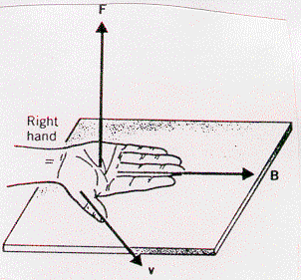

y

z

x

The third hand rule is:

1. The **fingers** point in the direction of the external magnetic field (B) from north to south.
2. The **thumb** points in the direction of the particle’s motion (v).
3. The **palm** indicates the direction of the resulting force on the particle (F).

Like the other hand rules, the right hand is used for positive charges and the left hand is used for negative charges.

For the following diagram, what is the direction of the deflecting force if the particle is:

A. an electron.

B an alpha particle.

N

S

x

A. Using the left hand (negative charge), the fingers point to the right and the thumb points into the page – the palm indicates a force **up the page**.

B. Using the right hand (positive charge), the fingers point to the right and the thumb points into the page – the palm indicates a force **down the page**.

# Magnitude of the deflecting force

The deflecting force on a charged particle moving through an external magnetic field is calculated using:



where

Fm deflecting force from the magnetic field (N)

B magnetic flux density or magnetic field strength (Tesla) (T)

q charge of moving particle (C)

v speed of particle (m/s)

❑ angle between  and 

The maximum deflecting force will occur when  and are perpendicular ( = 90o). Since sin 90o = 1



A 20 mg particle with a charge of +2.0 C enters a 0.020 T magnetic field at 90o to the field. If the speed of the particle is 40 m/s, what is the acceleration that is experienced by the particle in the diagram below?

The right hand rule tells us that the particle will be deflected upward out of the page.

+

N

S

 

What is the magnetic field strength if an electron traveling at 400 m/s experiences a deflecting force of 2.0 x 10-19 N when it enters at 90o to the field?



An alpha particle enters a 50 mT field at 30o to the field at a speed of 500 m/s. What is the deflecting force experienced by the alpha particle?



An 2+ particle has a charge of

2 x 1.60 x 10-19 C = 3.20 x 10-19 C.

# Particles in magnetic fields

When a charged particle enters a magnetic field at 90o to the field, the particle experiences a force which is perpendicular to its velocity. Consider the diagram below of a negative particle entering a magnetic field.

X X X X

X X X X

X X X X

−

X’s represent a magnetic field (B) acting into the page

Fm

X X X X B

The result is that while the speed of the particle is not effected, the direction of the particle’s motion changes. Recall from Physics 20 that a force acting perpendicular to the motion of an object results in **uniform circular motion**. Therefore, the magnetic force manifests as a**centripetal force**:

 (note that one of the v’s cancels out)

**Note**: For problems involving a particle entering a magnetic field the derivation of the relationship between speed, mass, charge, radius of curvature and magnetic field strength must be always be shown.

This is a very important relationship that we will be working with throughout the remainder of the course. Refer to Pearson pages 596 to 601 for a discussion of particle motion in a magnetic field.

An electron traveling at 6.0 x 106 m/s enters a magnetic field of 40 mT. What is the radius of the electron's path?



# Velocity selectors

FE

FB

●

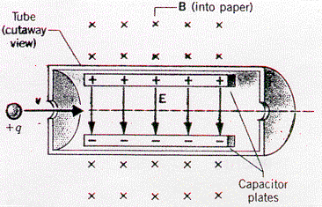

A **velocity selector** is a device for measuring the speed of a charged particle. The drawing shows a velocity selector that consists of a cylindrical tube located within a constant magnetic field B. Inside the tube there is a parallel plate system that produces a uniform electric field ⏐⏐. A moving charged particle, in this case a positive charge, experiences a magnetic force and an electric force at the same time. If the magnetic and electric forces are equal and opposite, the net force on the charged particle is zero resulting in the particle moving undeflected through the fields. The forces are balanced,



**Note**: For problems involving a velocity selector, the derivation of the relationship between speed, electric field strength, and magnetic field strength must be always be shown.

Note that only particles with a particular speed will pass through the selector. For particles with different speeds the forces will not be equal and the particle will be deflected away either up or down.

An electron enters an electric field (4.5 x 105 N/C) and a perpendicular magnetic field (2.5 x 10-2 T) and passes through both fields undeflected. What is the speed of the electron?



# Mass spectrometer (mass spectrograph)

An instrument that makes use of the combination of centripetal motion and magnetic deflection of charged particles is the **mass spectrometer**. A mass spectrometer is an instrument that separates particles according to their masses. Say, for example, a scientist wants to study the isotopes of lithium. Isotopes, you may recall from chemistry, have the same atomic number (number of protons) but a different atomic mass (number of protons + neutrons). The element is first placed in an ion generation and accelerator chamber where it is ionized (the atoms are stripped of their outer electrons) resulting in Li+ ions. The ions are then accelerated through an electric potential and they pass into the spectrometer. Since every ion has the same charge, speed and initial path, any differences in their circular paths are due to differences in mass – the lighter isotopes will travel in smaller circles than heavier isotopes.

Mass spectrometers have three basic parts:

1. ion source and accelerator
2. a velocity selector
3. an ion separator

Ion generation and acceleration chamber

mass spectrometer

ion separation chamber

velocity selection chamber

sample

x x x x x x x

x x x x x x x

x x x x x x x

x x x x x x x

+ + + + + + +

– – – – – – –

electrified plates

B⊥ 1

• • • • • • • •

• • • • • • • • • • • • • • • • • • • • • • • •

• • • • • • • •

ion detector plate

B⊥ 2

*Ion generator and accelerator*

Atoms are ionized either by extreme heating or by electrical discharge. The ions are then accelerated through a potential difference (V) where they gain kinetic energy (see Lesson 16).

*Velocity selector*

Once the ions pass through the accelerator opening they will have different speeds depending on the charge and mass of the ion. The ion separation chamber requires that the ions have the same speed so they are passed through a **velocity selector**. The velocity selector is composed of a uniform magnetic (B⊥ 1) and an electric field which are perpendicular to each other. The ion experiences a magnetic force in one direction and an electric force in the opposite direction. If the forces are balanced,



only particles with a certain speed will pass through the selector. For particles with different speeds the forces will not be equal and the particle will be deflected away from the entry point into the ion separator.

*Ion separator*

After leaving the velocity selector, the charged particles enter a different magnetic field (B⊥ 2) that deflects the ions in a circular path.



An ion detector marks the point where the ion contacts the detector plate. The radius of the circular path can then be measured and the mass of the isotope is calculated.

Uranium isotopes, uranium–235 and uranium–239, can be separated using a mass spectrometer. The uranium–235 isotope travels through a smaller circle and can be gathered at a different point than the uranium–239. During World War II, the Manhatten project was attempting to make an atomic bomb. Uranium–235 is fissionable but it makes up only 0.70% of the uranium on Earth. A large mass spectrometer at Oakridge, Tennessee was used to separate uranium–235 from the raw uranium metal.

Uranium–235 and uranium–239 ions, each with a charge of +2, are directed into a velocity selector which has a magnetic field of 0.250 T and an electric field of 1.25 x 107 V/m perpendicular to each other. The ions then pass into a magnetic field of 2.00 mT. What is the radius of deflection for each isotope?

A charge of +2 means that each ion has lost two electrons. Therefore

q = 2 x +1.60 x 10-19 C = +3.20 x 10-19 C

Since each proton and neutron has a mass of 1.67 x 10-27 kg, the mass of each isotope is.

m235 = 235 x (1.67 x 10-27 kg) = 3.9245 x 10­-25 kg

m239 = 239 x (1.67 x 10-27 kg) = 3.9913 x 10-25 kg

For the velocity selector:



For the ion separator



# Van Allen radiation belts

When a charged particle enters a large magnetic field at an angle between 0o and 90o, the particle will begin to spiral toward one of the magnetic poles. The spiral results from part of the particle's velocity being converted into circular motion and the remainder keeps the particle moving along a path perpendicular to the rotation of the circular component.

The Earth has a large magnetic field surrounding it. Incoming charged particles from the sun interact with the magnetic field and spiral toward either the north or south pole. When they eventually enter the Earth's atmosphere, the collisions between the particles and the atmospheric gases create the Aurora Borealis (northern lights) and the Aurora Australis (southern lights). If the magnetic field was not there, the charged particles may reach the Earth's surface and may be harmful to life.

In 1958, a team of scientists finally confirmed the existence of the spiraling particles. The magnetic field area containing the charged particles is now called the Van Allen Radiation Belt in honor of the scientist leading the team.

# Black and white television

Since a magnetic field changes the path of a moving electron, a properly designed field can direct an electron wherever the designer wishes. In a television picture tube, electrons are fired through a potential difference of about 50000 V and are then directed by horizontal and vertical magnetic coils toward the front of the picture tube – the TV screen. The screen is coated with a thin film of phosphorus material. When an electron hits the coating, the coating glows for a brief instant. Thus, if the electrons are properly directed, a picture can be formed.

magnetic coils

phosphorous screen

electron gun

An image on the TV screen is actually a series of still pictures seen in rapid sequence. As in motion pictures, the impression of motion is only an illusion. But in TV, you do not see one complete picture at one time. Each picture on the screen (there are 30 complete pictures being scanned every second) is sketched by a moving spot of varying intensity. The spot is produced as the electrons strike the coating and produce visible light. To produce a single complete picture, the spot traces 525 lines. This means that the electron beam makes 15750 horizontal passes every second. The electron beam must be controlled with great speed and precision.

# Practice problems

1. For the following diagram, what is the direction of the deflecting force if the particle is:

A. a proton.

B. a fluoride ion.

S

N

x

2. Trace out the path of the positive particle in the indicated magnetic field.

B

•

•

•

•

•

•

•

•

•

•

•

•

•

•

•

•

•

•

•

•

•

•

•

•

•

•

•

•

•

•

+

3. What is the magnetic field strength if a deflecting force of 0.0010 N is produced on a 7.5 C particle entering the field at 30o with a speed of 30 m/s? (8.89 mT)

# Hand-in assignment

1. What is the difference between a permanent magnet and an electromagnet?

2. The poles of a horseshoe magnet are arranged so that the North Pole is directly over the South Pole. A negatively charged object passes between the poles from left to right. What is the direction of the resulting force? (Draw a diagram.)

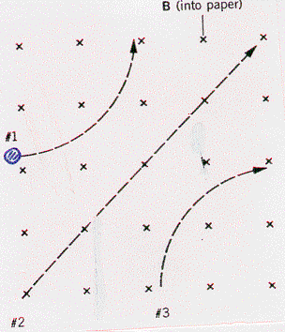

3. Three particles move through a constant magnetic field and follow the paths shown in the drawing. Determine whether each particle is positive, negative or neutral. Give reasons for your answers.

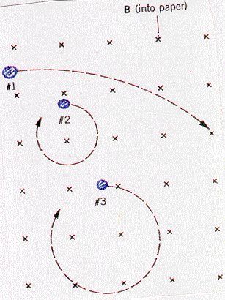

4. Three particles have identical charges and masses. They enter a constant

magnetic field and follow the paths shown in the picture. Which particle is moving

fastest, which is moving slowest? Justify your answer.

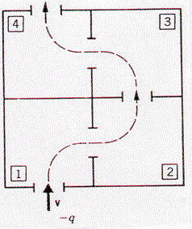

5. The drawing shows a top view of four interconnected chambers. A negative charge is fired into chamber 1. By turning on separate magnetic fields in each chamber, the charge can be made to exit chamber 4.

(a) Describe how the magnetic field in each chamber should be directed.

(b) If the speed of the particle is **v** when it enters chamber 1, what is its speed when it exits chamber 4? Explain.

6. What deflecting force is exerted on a charge of 40 C moving at 15 cm/s at 30o to the magnetic field whose flux density is 0.025T? (7.5 x 10-8 N)

7. What happens to the motion of an electron that is moving in the same direction as (i.e. parallel to) the magnetic field which it enters?

8. What is the deflecting force on an alpha particle moving at 1.0% of the speed of light directly across a magnetic field whose flux density is 0.0030 T? (2.9 x 10-15 N)

9. An electron and a proton, each with a speed of 1.2 x 102 m/s enter a magnetic field of 0.0020 T at 90o to the field as shown below.

S

N

A. Calculate the force on each particle. (3.84 x 10-20 N)

B. Calculate the acceleration experienced by each particle. (4.2 x 1010 m/s2 out of page, 2.3 x 107 m/s2 into page)

10. A magnesium ion (Mg2+) traveling at 60 000 m/s enters a mass spectrometer with a magnetic field of 0.0800 T at an angle of 90o to the field. What is the radius of the curve followed by the magnesium ion? (9.39 x 10-2 m)

11. Calculate the magnitude and direction of the magnetic force on an alpha particle moving south at a speed of 7.40 x 104 m/s through a vertically upward magnetic field of 5.50 mT. (1.30 x 10-16 N west)

12. The solar wind is a thin hot gas given off by the sun in all directions. Some of the charged particles enter the magnetic field of the Earth and can experience a magnetic force. Suppose some charged particles traveling at 9.0 x 106 m/s encounter the Earth's magnetic field at an angle of 90o where the magnitude of the field is 1.2 x 10-7 T. Find the radius of the circular path on which the particle would move it were (a) an electron and (b) a proton. (4.3 x 102 m, 7.8 x 105 m)

13. An alpha particle with a speed of 4.4 x 105 m/s moves perpendicular to a 0.75 T magnetic field in a circular path with a radius of 0.012 m. What is the magnitude of the charge on the helium nucleus? (3.2 x 10-19 C)

14. An ion source in a particular mass spectrometer produces deuterons (a deuteron has twice the mass of a proton, but the same charge). Each deuteron is accelerated from rest through a potential difference of 2000 V after which it enters a 0.600 T magnetic field. Find the radius of the circular path. (0.0152 m)

*15. An electron, traveling at a speed of 3.62 x 106 m/s, enters a magnetic field with a strength of 0.0373 T at an angle of 75o to the magnetic field lines. when it enters the magnetic field, the electron has a helix spiral (corkscrew) path. What is the distance between the spirals? (8.73 x 10-4 m)

16. Consider the following diagram that represents an electron moving into the plane of the page.

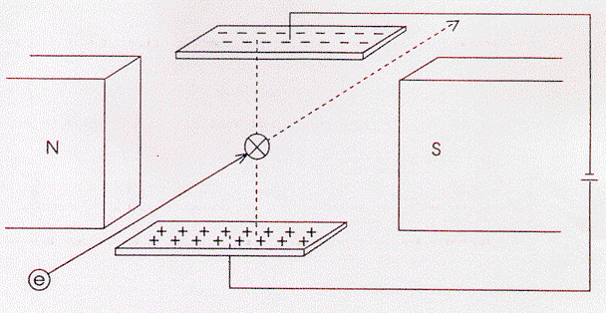

V = 2000 V between charged

plates

d = 0.080 m between charged

plates

B = 0.0028 T

The electron enters the electric field, which is perpendicular to the magnetic field, and passes through both fields undeflected. The diagram indicates an electron moving into the page.

A. Draw vectors on the diagram to indicate the direction of Fm and Fe on the electron.

B. Calculate the speed of the electron. (8.9 x 106 m/s)

17. A double charged unknown ion is shot into a 0.845 T magnetic field between two parallel plates which are 4.00 mm apart. When a potential difference of 56.8 kV is applied across the plates, the particle passes undeflected through the fields. When the voltage is turned off, the particle has a radius of curvature of 4.15 m.

A. What is the speed of the particle? (1.68 x 107 m/s)

B. What is the mass of the particle? (6.68 x 10-26 kg)

C. Identify the ion. (Ca2+)